**DAILY ONLINE ACTIVITIES SUMMARY**

|  |  |  |  |  |  |
| --- | --- | --- | --- | --- | --- |
| **Date:** | | **22/06/2020** | **Name:** | **JASLINE SHARON TAURO** | |
| **Sem & Sec** | | **4th sem, A Section** | **USN:** | **4AL18CS029** | |
| **Online Test Summary** | | | | | |
| **Subject** | **----** | | | | |
| **Max. Marks** | **----** | | **Score** | **----** | |
| **Certification Course Summary** | | | | | |
| **Course** | | Software development engineer | | | |
| **Certificate Provider** | | **AWS Educate** | **Duration** | | **3 hrs.** |
| **Coding Challenges** | | | | | |
| **Problem Statement:**  Write a Java Program for Modular Exponentiation. | | | | | |
| **Status: EXECUTED** | | | | | |
| **Uploaded the report in GitHub** | | | **YES** | | |
| **If yes Repository name** | | | <https://github.com/jaslinesharontauro/JAVA_Prgms> | | |
| **Uploaded the report in slack** | | | **YES** | | |

Online Test Details: (Attach the snapshot and briefly write the report for the same)

Certification Course Details: (Attach the snapshot and briefly write the report for the same)

Coding Challenges Details: (Attach the snapshot and briefly write the report for the same)

CERTIFICATION COURSE DETAILS:

Today I have started the new course “Software Developer Engineer” by AWS Educate. In this course today I learnt about Databases and Data structures. Today I have completed this course. And I have also completed the final assessment and final project of this course.

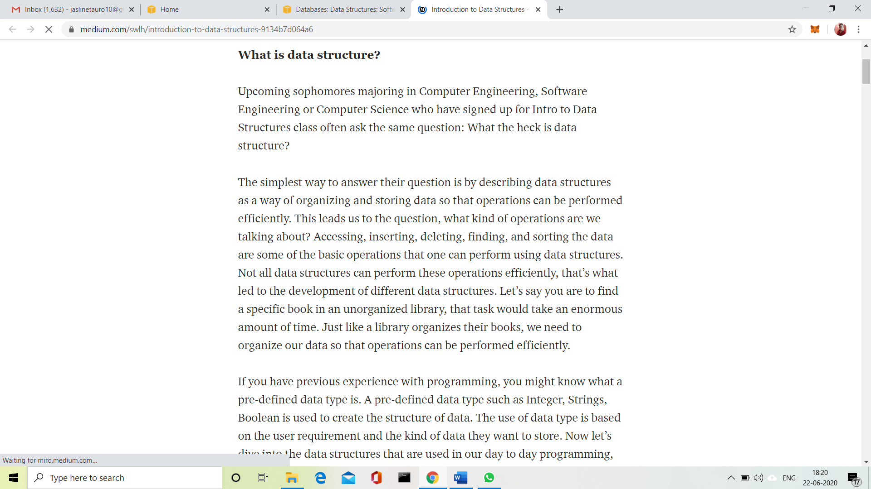

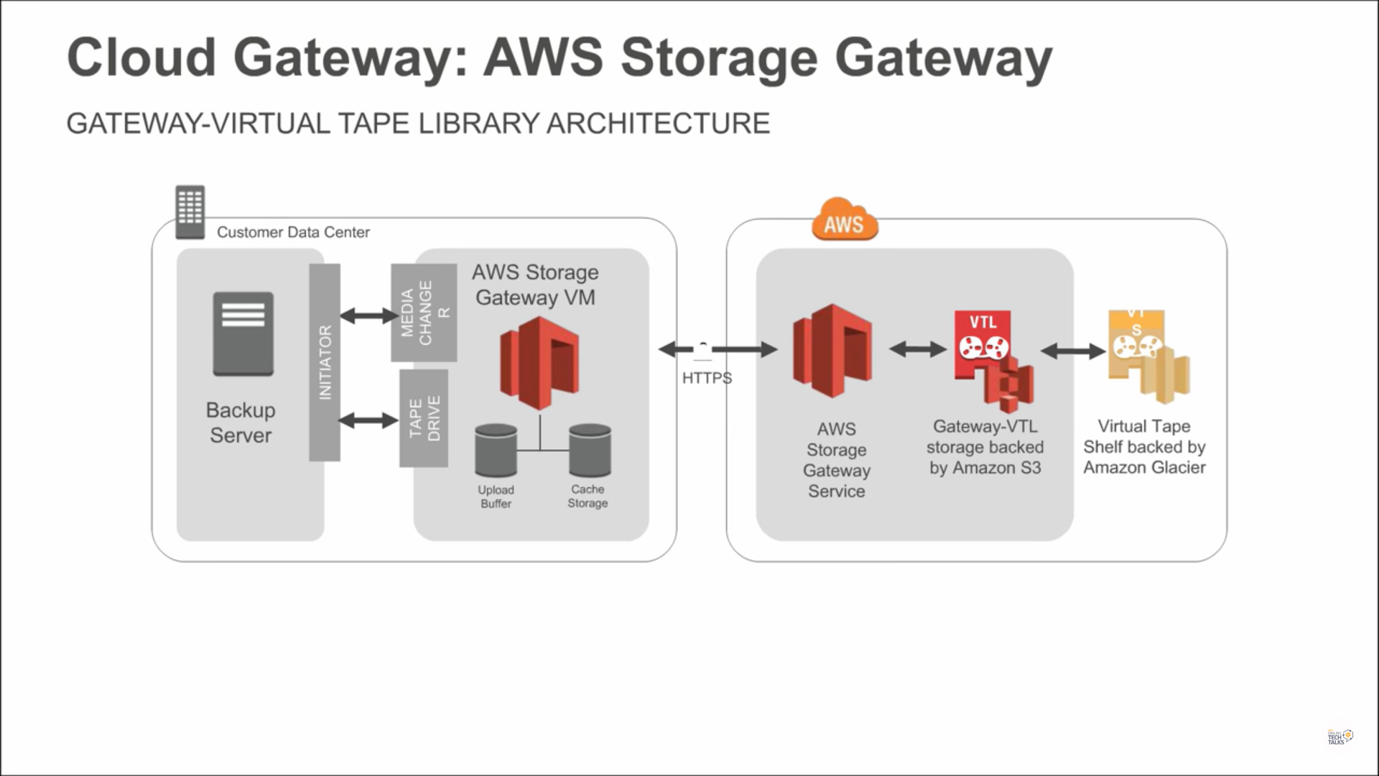

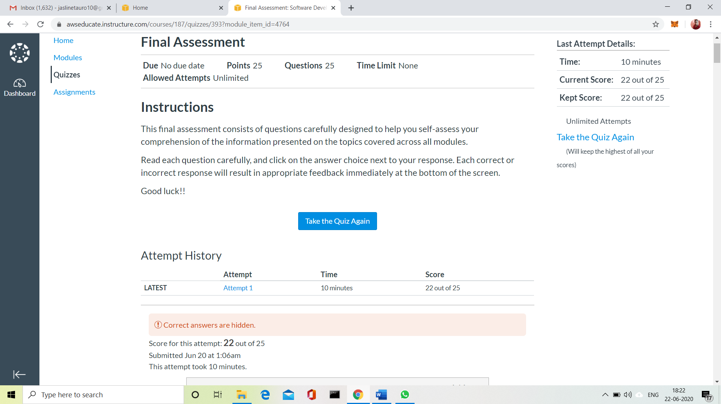

WEBINAR DETAILS:

Today I attended an Webinar on the topic “Trends in IT Domain” By Rahul. This session was very Interesting.





CODING CHALLENGES:

Problem Statement 1:

Write a Java Program for Modular Exponentiation.

Given three numbers x, y and p, compute (xy) % p.  
Input: x = 2, y = 3, p = 5

Output: 3  
Explanation: 2^3 % 5 = 8 % 5 = 3.

Input: x = 2, y = 5, p = 13  
Output: 6  
Explanation: 2^5 % 13 = 32 % 13 = 6.

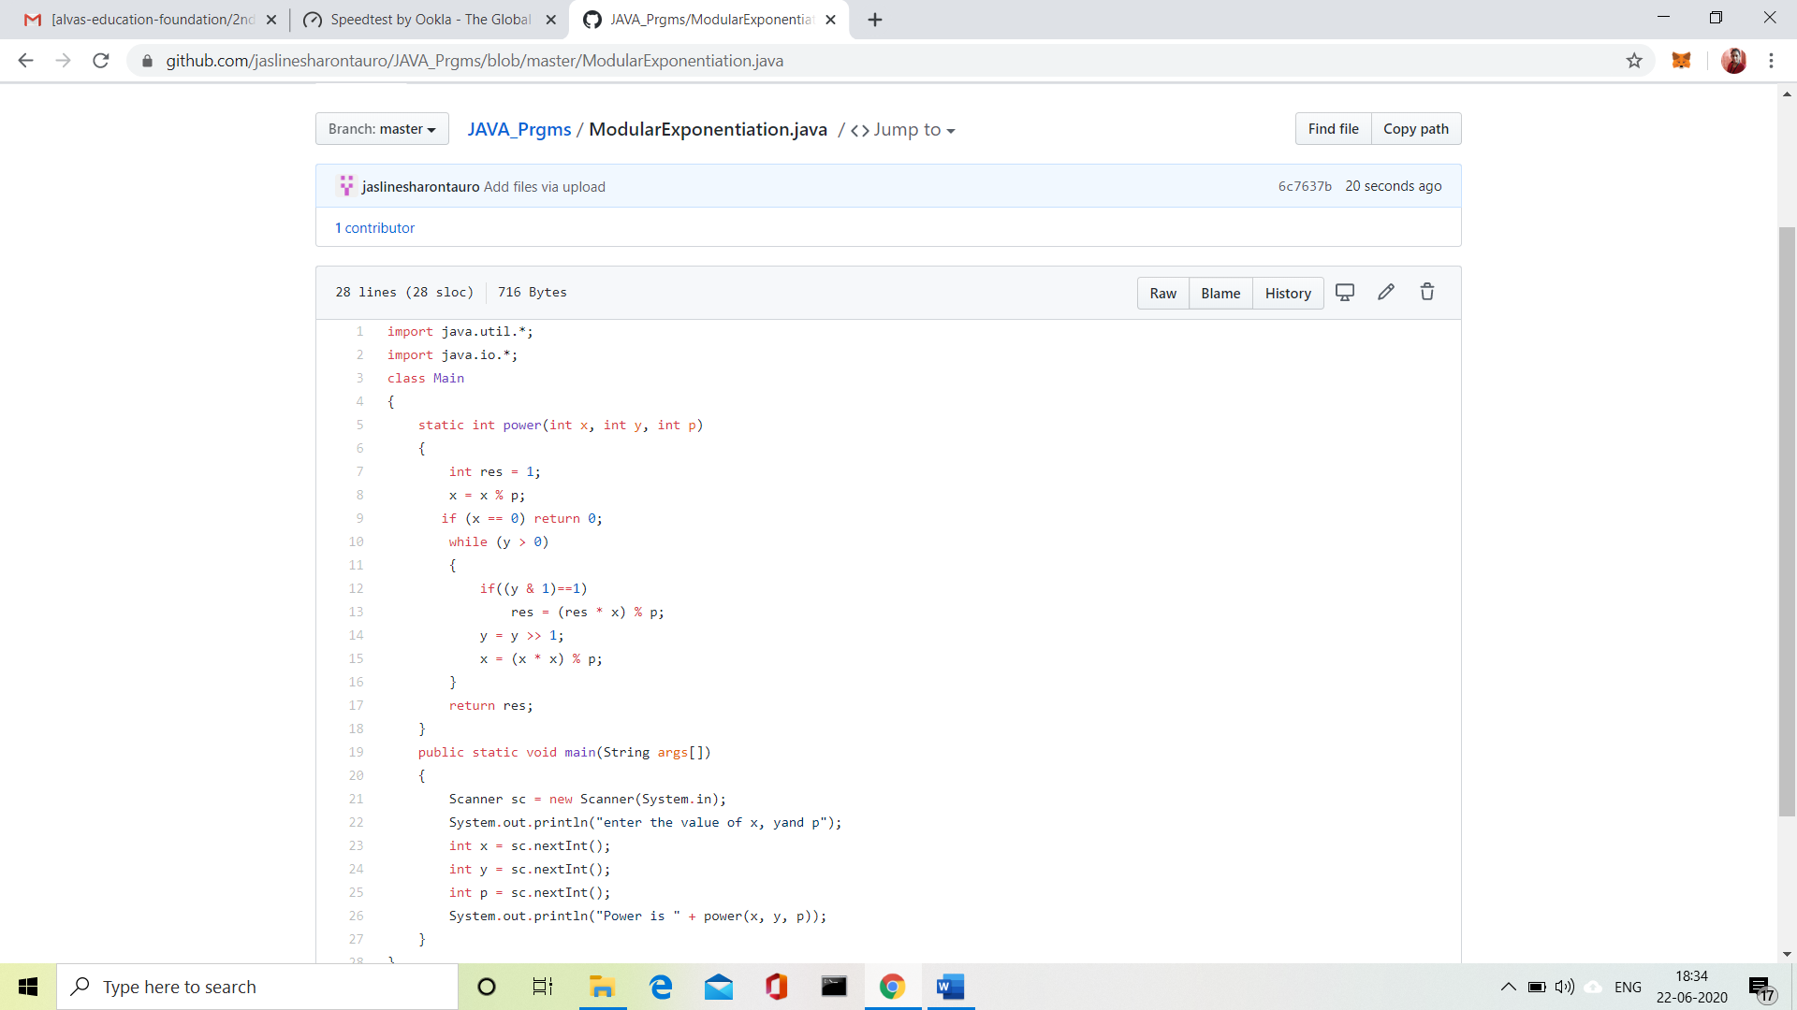

 Solution uploaded in GitHub.